**Conditional Formatting**

* Create a Gantt chart for the data provided
  + A data set is provided which contains Activity and the date on which it was performed
  + You need to create a Gantt chart for the dataset provided using conditional formatting
  + You can play with data if you want
  + A sample Gantt chart:

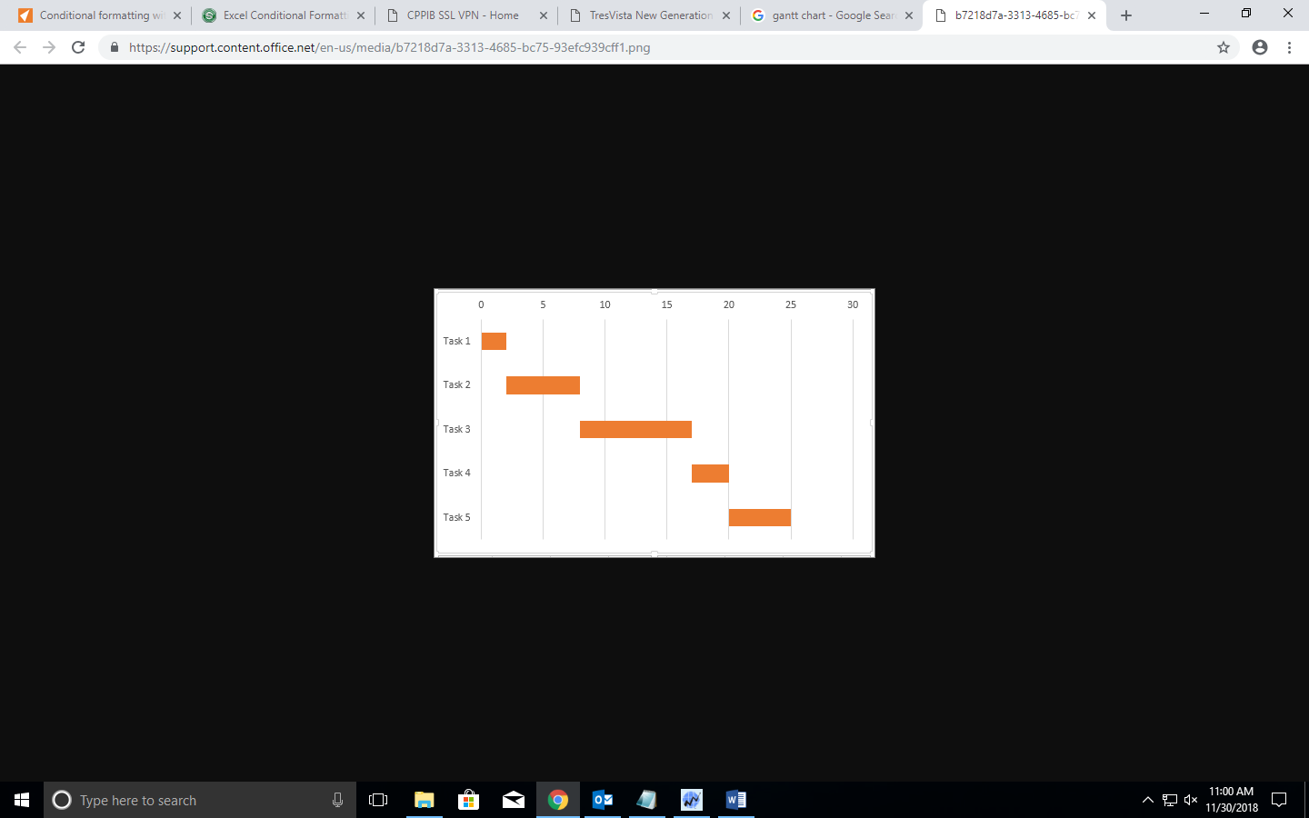

*You can refer more examples online*

**Dashboard (Pivot Chart & Table)**

* Summarize the Pokémon dataset
  + A Pokémon dataset is provided to you, please understand the data first
  + Represent “***sp_attack***”and “***sp_defense***”, classified based on their type
  + Play with data and create a summary report (Be innovative!)

**Conditional Dropdown**

* Create a Pokémon dashboard
  + Create two dropdowns, one for ***“type”*** and another for ***“Pokémon Name”***
  + After selecting the pokemon, their ***“sp_attack”*** and ***“sp_defense”*** should be displayed